Name __________________________________ Sect ____________________
3rd MP Review Packet:
100-point assignment: 50 point assignment for completing and showing all work
50 point XC opportunity based on percentage correct.

Example: Packet score = 80 percent
40/50 for quiz grade
40 XC points for quiz category in Gradebook

ALL WORK MUST BE SHOWN TO RECEIVE CREDIT!!!
SHOW WHAT YOU KNOW. SHOW SET-UP AND SUPPORTING WORK WHEN APPLICABLE.

All problems are topics we’ve studied in class during the third marking period. Use your journal, classwork, homework, and graded tests as a resource to show and solve the problems.

Functions
Identify whether the following tables represent functions or non-functions: (1 pt each)

x y x y x y x y
-2 3 3 8.5 -7 42 8 10
-4 4 2 8.5 -7 40 3 9
-6 5 1 8.5 -7 38 -11 15
-7 6 0 8.5 -7 36 5 -4
-8 7 -1 8.5 -7 34 3 9

____________ _____________ _____________ _____________

The following equations all represent functions. Identify which functions are linear vs. non-linear functions. (1 pt each)

f (x) = 2x – 3.5 ________________

f (x) = 3x² – 10x – 8 ________________

f (x) = 3x + 5 – x ________________

f (x) = x (2x + 4) ________________
(ctd, next page)
(Continued from previous page – identify whether the function is linear or non-linear):

The weight of a soda bottle compared to how full it is: ________________

The volume of a cube compared to the length of one side: ________________

Complete the following table for the function f (x) = x² – 8 . (2 pts)

x f(x) = x² – 8 y
-3
-2
-1
0
1
2
3

Based on the above table, graph the function (2 pts):

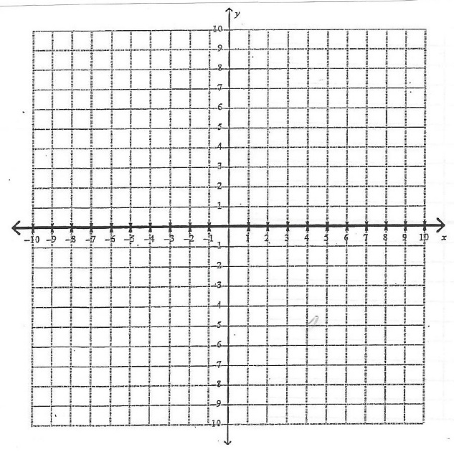

List two reasons why this is not a linear function (2 pts):

__________________________________________________________

Scatterplots
Make a scatterplot using the following table. Clearly identify the x and y variables, and label the axis on your graph, and show the appropriate scale of the graph. (4 pts)

Ralph the ranger is in charge of monitoring the tree growth in the local park. The following table shows the height of various trees in the park compared to their age.

Age (in years): 4 7 2 8 3 10 2 6 5 9 8

Height (in feet): 10 16 6 20 8 22 8 24 12 20 16

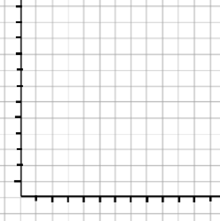

What type of correlation does this scatterplot show? (1 pt) _______________________

Identify any outliers (1 pt): ___________

Using a straight edge, draw a line of best fit that represents the overall sampling of data. (1 pt)

Using the graph and the line of best fit you drew, write a linear equation to represent the line of best fit and the data sample. Write your equation in slope-intercept form. (3 pts).

Using the linear equation you just wrote for the line of best fit, make a prediction as to how tall a 15-year-old tree would be. (2 pts)

Systems of Linear Equations
Solve the following systems of linear equations. You may use the graphing, substitution, or elimination methods (3 pts each)

y = 2x – 8
y = -x + 7 Solution: ________________

3x – 2y = 14
x + 2y = -6 Solution: ________________

At Shop-o-Rama, they sell hot dogs in packs of 6, and hot dog buns in packs of 8. Mrs. Richards goes to the story and buys a total of 12 packages, which consist of a total of 82 individual items. How many packs of hot dogs and how many packs of buns did she buy?

Identify what your variables represent (1 pt) :

X = ____________
Y = ____________

Write your equations (2 pts):

________________________

________________________

Solution : Show your work. (2 pts) : ___________________

Transformations

Transform the following figures as indicated. Draw the original figure, show the rule you use to identify the new coordinates, clearly list the new points, and graph the new image
(4 pts each):

A triangle with the points (1, 8), (5, 2), (9, 4)
Reflect across the x axis:

A rectangle with the points (-3, 7), (2, 7), (-3, -2), (2, -2)
A translation 4 units to the right, and 5 units down

A rectangle with the points (2, 3), (9, 3), (9, -1), and (2, -1)
A 270˚ rotation

A quadrilateral with the points (-9, 0), (-6, 6), (-3, 0) and (-6, -9)
A dilation with a scale factor of $\frac{1}{3}$

Multi-Step Equation Practice:
Solve each equation for the missing variable. Show all work. (2 pts each):

3x + 7 = 4x + 2 2x + 5 + 8x = 75 3x² + 7 = 82

3 (2x – 5) + 9 = x + 14 ½ (4x – 6) = x – 5 $\frac{2x+5}{3}=11$

$\frac{2x}{3}+5=11$ $\frac{2}{3}$x + $\frac{4}{3}$x – 4 = -3x + 26 11x + 8 = 7x – 44

Word Problems:

Clarence has a bag of marbles, with three colors: blue, yellow and white. He has a total of 44 marbles, twice as many yellow marbles as he has blue marbles, and 4 fewer white marbles than blue marbles. How many blue marbles does he have? Set up your equation, and show all work. (4 pts)

Three consecutive numbers add up to 120. What are the numbers? Set up your equation and show all work (4 pts)

