Name ______________________________________________ Sect ______________________

End of 3rd Marking Period – XC. Year in Review. 8th Grade

The following questions have all been taken from assignments that you have completed during the first three marking periods.

All assignments that ARE COMPLETE and turned in will automatically receive 75 XC points.

Partially completed assignments, or assignments where no work is shown will not be graded and you will receive no XC points.

In addition, packets will be graded for correctness, and your score will be added to XC points. This means you have up to 175 XC points available!!!

In its simplest definition, a rational number is any number that can be written as a

______________________________________________________

Convert the following fraction to decimal: Convert the decimal to a fraction. Simplify:

$\frac{4}{12}$ _________________ .55 _________________

PEMDAS:

Simplify:

(13 – 4)² + 3² – 7 • 4

Functions:

For each term, indicate whether it refers to the x variable, or the y variable:

Independent variable _______ Range _________ Input ________

Domain _______ Output _________ Dependent Variable _______

Identify which is a function and which is not a function:

X Y X Y X Y X Y
1 4 2 -2 3 11 12 1
2 4 6 -8 -3 -11 6 ½
3 4 -8 6 0 0 3 ¼
4 4 6 14 3 11 0 0

Exponents and Roots:

Simplify: (2 point each)

Example : 2³ = 2 • 2 • 2 = 8

7⁻² 3⁻⁵ (-4)³

Simplify: Leave your answer in exponent form. (2 points each)

6⁴ • 6³ 9³ • 9⁻⁵ 7¹¹ ÷ 7⁸ (-6)³ ÷ (-6)⁵

Approximate each square root to the nearest 100th.

√58 √146

Factor and simplify each square root. Leave answers with radical signs.

√45 √98

Scientific Notation:

Express in Scientific Notation:

287,000,000

Express in Standard Notation:

2.15 x 10⁻⁴

Solve:

(3.6 • 10⁵) + (8.22 • 10⁴) (8.99 • 10⁸) - (6.2 • 10⁶)

(6.6 • 10⁻⁵) $×$ (2.2 • 10⁻³) (8.84 • 10⁹) ÷ (2.6 • 10⁴)

Pythagorean Theorem:

Solve for the missing side:

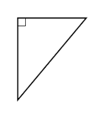
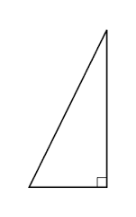

12 x 26 24

16
x

Lines and Angles:

Two angles that add up to 90 ͦ are called _____________________ angles.

Two angles that add up to 180 ͦ are called ______________________ angles.

Complete the missing angle measurements:

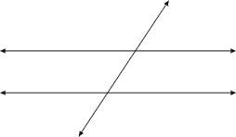
A ______

129 ͦ A B ______
B C
C ______
D E
F G D ______

E ______

F ______

G ______

Proportions:

Are the following rates proportional? Show your work.

$\frac{6}{7} \frac{36}{40}$ $\frac{65}{117} \frac{5}{9}$

Complete the missing variables.

$\frac{12}{14} = \frac{18}{x}$ $\frac{x}{84}= \frac{35}{294}$

Are the following figures similar?
4 6 8
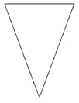
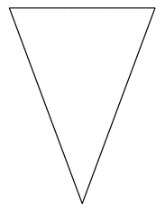
9 9
6 2
12 12
3.5

Dilations:

A rectangle measures 4.5 cm by 8 cm. It is dilated with a scale factor of 5. What are the new dimensions?

A Triangle is plotted on the coordinate plane with coordinates (-2, 3), (1, 2) and (3, -1). It is dilated with a scale factor of 3. List the new coordinates and graph both triangles.

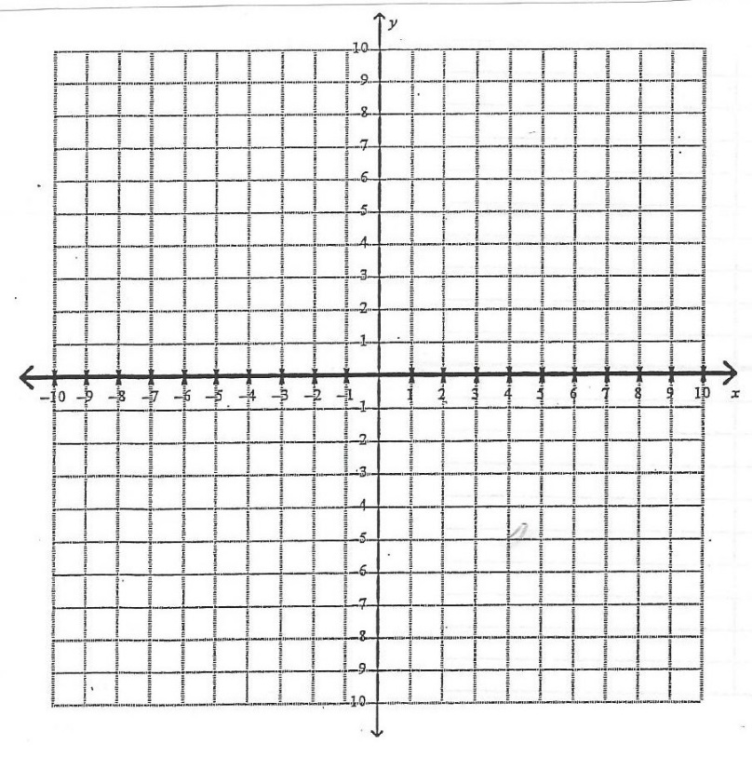

Transformations:

Transform the following figures as indicated:
List the new coordinates. Graph both the original image and the transformed image.

A triangle with coordinates (2, 5) (3, -1) and (6, 2)
Reflect across the y axis.
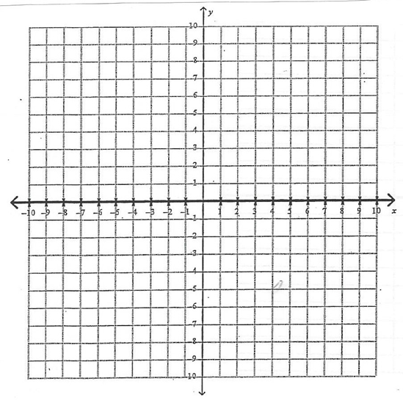

A quadrilateral with coordinates (3, 5) (-1, 5) (-4, -2) and (3, -4)
Rotate 90 ͦ
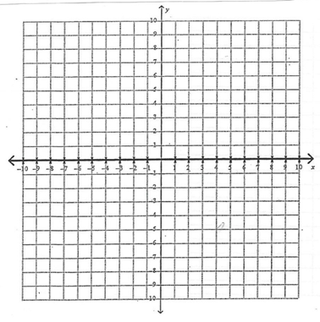
Literal Equation:
The formula for volume of a rectangular prism is V = L • w • h. Solve for w.

