Name ______________________________________________ Sect ______________________

Solve each system of linear equations by graphing. Graph your lines CAREFULLY. Check your work.

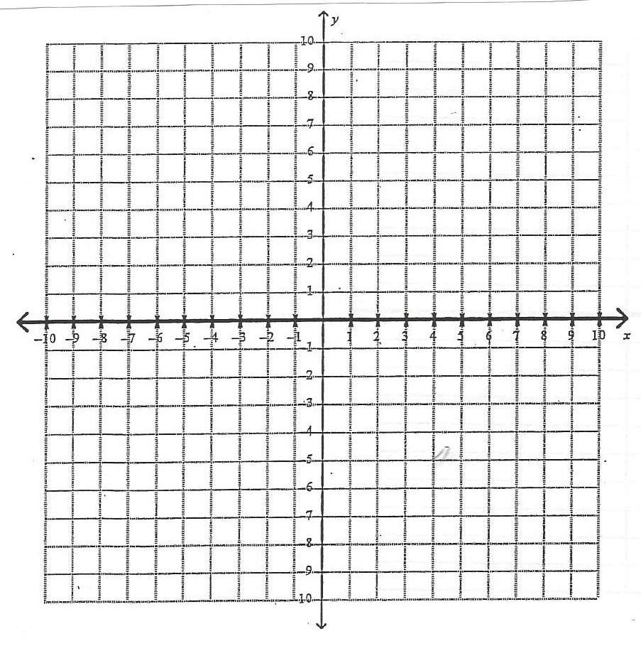y = 3x – 2

y = x + 2
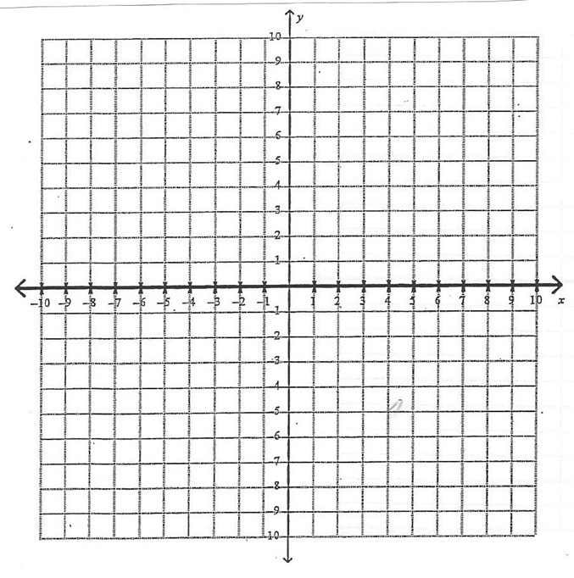y = x + 2

y = 2x – 4
y = $-\frac{1}{2} x+7$

y = $-\frac{5}{2} x-1$
y = 2x – 1

y = 3x – 6
y = x + 2

y = $-\frac{2}{3} x-8$

