Name ______________________________________ Sect _________________
Functions Unit Review:

Determine whether each ordered pair is a solution of $y= -\frac{1}{3} x+4$

1. (3, 7) 2. (-3, -4) 3. ($9, 7)$ 4. (6, 6)

5. Graph the points and find the distance:

Between (-8, 2) and (-8, -5)

Between (-2, 6) and (9, 6)

Between (4, -7) and (4, 0)

Make a table and a graph for each function

y = 4x + 1 y = $-2x+ 5$

X 4x + 1 Y X $-2x+5$ Y
-2 -1
-1 0
0 1
1 2
2 3
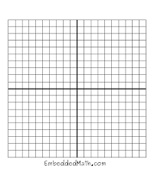

Identify which is a function and which is not a function:

X Y X Y X Y X Y
1 2 3 4 -15 -20 17 24
2 3 4 5 -10 -20 11 -8
3 4 5 6 -10 -20 33 1
4 5 4 7 -10 -20 -8 11
5 6 3 8 -5 -10 33 1

9. The following table represents the weight of an adult male as he grows older. Make a graph to represent the data shown in the table: (3 pts)

Age: 20 25 30 35 40 45
Weight (lbs) 160 167 174 181 188 195

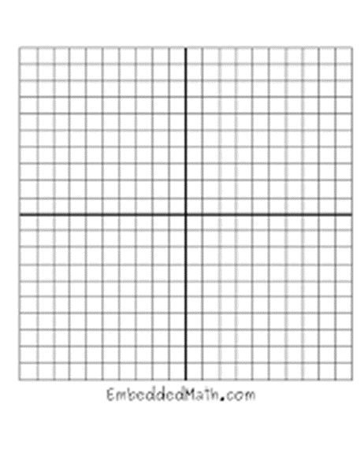

The book-of-the-month club charges a $15 yearly membership fee plus $3 for every digital book downloaded. This function is represented by the equation y = 3x + 15. Make a table of values to show the cost if we order 2 books, 4 books, 6 books, 8 books or 10 books. Then use the table to create a graph.

X Y

What is the domain of this function?

What is the range of this function?

The following tables represent functions. Use the table to write an equation:

X Y
-1 4
0 9
1 14
2 19
3 24

When x increases by 1, how much does y increase by? ________________________

If the input (x) was 0, what would y equal? __________________________

Write the equation for the function. _________________________

X Y
3 1
4 1.5
5 2
6 2.5
7 3

When x increases by 1, how much does y increase by? ________________________

If the input (x) was 0, what would y equal? __________________________

Write the equation for the function. _________________________

A mountain climber starts out at an altitude of 100 feet. He begins a strenuous climb and ascends an additional 50 feet every hour.

Make a table to represent this function, using the input values 0 hours, 1 hour, 2 hours, 3 hours and 4 hours. Then based on the table, graph this relationship on the coordinate plane.

X Y

