Name __________________________________________________ Sect ________________

Homework: Graph the points listed on the coordinate planes. Identify the quadrants for each point. Then find the distance between the points.

(1, 5) (6, 5) (1, 5) (-3, 5)
Q ____ Q _____ Q ____ Q _____
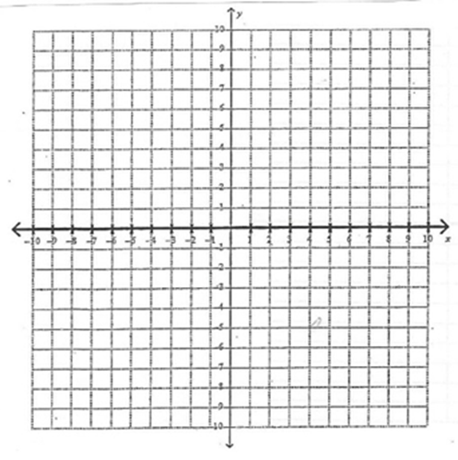

(0,-3) (0, 6) (5, -9) (5, 9)
Q ____ Q _____ Q ____ Q _____

(-4, -4) (4, -4) (5, 3) (5, -9)
Q ____ Q _____ Q ____ Q _____

(0, 0) (-8, 0) (7, 0) (7, -8)
Q ____ Q _____ Q ____ Q _____
