Name ______________________________________ Sect _________________

Make a table and a graph for each function

Y = ½ x + 3 y = 4x + 11

X ½ x + 3 Y X 4x + 11 Y
2 0
4 2
6 4
8 6

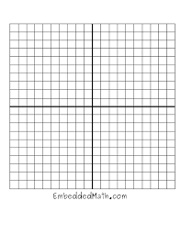

An airplane takes off at 1pm. At 1:15 the plane is at 2,000 ft altitude. At 1:30 the plane is at 4,000 ft. At 1:45 the plane is at 6,000 feet and at 2:00 the plane is at 8,000. Make a table and a graph to represent this function.

X Y

The temperature is Snowville is -20 degrees at 6am. At 7am the temperature is -5 degrees. At 8am the temperature is 10 degrees. At 9 am the temperature is 25 degrees and at 10 am the temperature is a balmy 40 degrees.

Make a table to represent this function and graph it.

X Y

