Name ________________________________________ Sect __________________

3D Volume Review

Identify the type of 3D figures shown below, and calculate the volume:

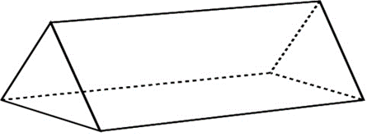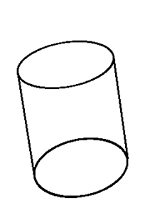

Figure: _______________ Figure: ______________ Figure: ______________

Vol: _________________ Vol: _________________ Vol: ________________

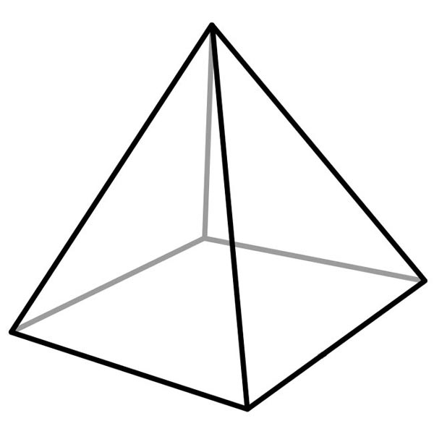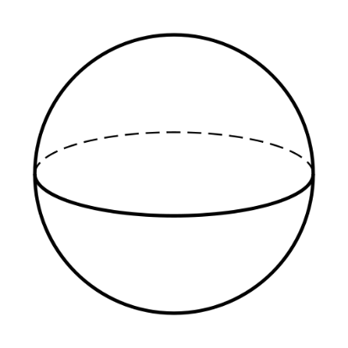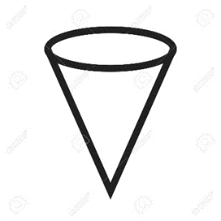

Figure: _______________ Figure: ______________ Figure: ______________

Vol: _________________ Vol: _________________ Vol: ________________

Word Problems: Identify the shape that is described and calculate the volume: (5 pts each)

The dwarf planet Ceres lies between Mars and Jupiter in our Solar System’s asteroid belt. It has a diameter of 587 miles. What is the volume of this dwarf planet?

If a soda can measures 17 cm tall and measures 7.6 cm across the surface of the lid, how much volume can the soda can hold?

Tovi’s Texas Taco Truck sells Tacos packed into ice cream cones. (It’s the most brilliant idea ever!) Yum!!!! If a cone measures 8.25 inches tall, and measures 3.75 inches across the mouth of the cone, how much mouth-watering deliciousness packs inside the cone?

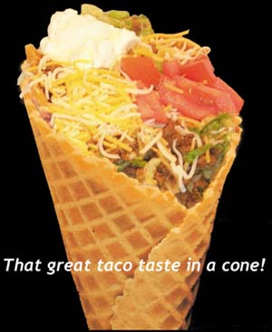

Finding Dimensions: (4 pts each):

A shipping crate can hold 36.5625 cu m of supplies. If the crate measures 3.25 m high, and 4.5 m long, how wide must the crate be?

As a sales tool, the Great Pyramid gift shop in Memphis packs its merchandise into pyramid-shaped gift boxes like the one shown below. If the square base measures 11” by 11”, and the volume of the box is 484 cubic inches, what is the height of the gift box?

