Name __________________________________________ Sect __________________

Linear Equations: Review.

Find the slope of each line:

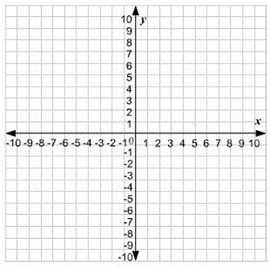

m = _________ m = __________

Find the slope of a line that passes through the points,

(1, 7) (3, -2) (-10, 4) (-5, -6)

m = ______________ m = ___________

Draw a line through the given point with the given slope.

(5, 2); m = -2 (-6, -9) ; m = $\frac{1}{3}$

Identify the slope and y-intercept from the following equations. Then graph the equations.

y = -4x + 8 y = $\frac{3}{2} x-5$

m = ___________ m = ____________

b = ___________ b = ____________

Put the following equations into slope-intercept format. Identify the slope and y-intercept. Then graph the equations.

6 – 3y = 12x $\frac{10y-5x}{3}=5$

m = ___________ m = __________

b = ___________ b = ___________

Write a linear equation for a line that goes through the points listed. Identify the slope and y-intercept. Then graph the equation.

(0, 3) (4, -1) (0, 2) (-8, -14)

m = ________ m = _________

b = ________ b = _________

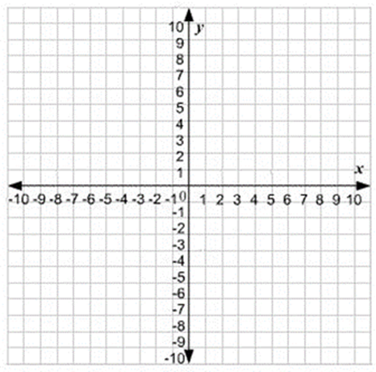

(-8, 2) (4, -4) (10, -2) (-5, 1)

m = ________ m = _________

b = ________ b = _________

To buy season tickets to the Eagles, one must first buy a seat license for a fixed fee, and then pay for tickets per game. The seat license costs $300, and after 5 games Joey Bagadonuts has paid a total of $550 including the seat license and game tickets.
Identify the slope and y-intercept, write a linear equation, and graph the equation. Be sure to label your x and y axis, and identify the scale of your graph.

m = ____________ b = _____________ Equation = ___________________

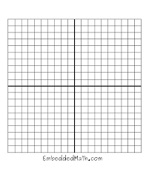

Two full water tanks are different sizes. The first one holds 300 gallons and drains at a rate of 5 gallons an hour. The second water tank is 180 gallons and drains at a rate of 3 gallons an hour.

Write a linear equation for each water tank:

If both tanks begin draining at the same time, after how many hours will they have the same amount in the tanks?

