Name __________________________________________ Sect __________________

Graphing Practice: HW
In most cases, we have to scale our graphs to accommodate the range of x and y values.

For the linear equations below, identify the slope and y-intercept of the equations. Graph the equations so they are represented accurately on the graphs provided.

Scale your x and y axis appropriately, and make sure the slope accurately reflects the scale you have determined. Be clear as to the scale on your graphs.

y = 5 x -35 m = ________

b = ________

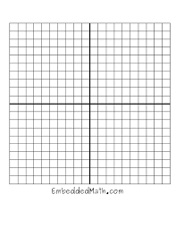

y = 7x – 42 m = _______

b = ________

y = 300x – 800 m = __________

b = _________

At the start of the baseball season, the Phillies have zero wins. After 4 months, they have 80 wins. Write a linear equation for this relationship, identify the slope and y-intercept, and graph the equation. Be sure to accurately show the scale of both your x and y axis.

Equation: m = ________

b = ________

The Mobius sisters have a joint savings account, from which they withdraw money. At the beginning of the year, the account has $1600. After 8 months, the account now has $400. Write a linear equation for this relationship, identify the slope and y-intercept, and graph the equation. Be sure to accurately show the scale of both your x and y axis.

Equation: m = ________

b = ________

Mr. Colley is tracking the growth of his plants in science class. After 3 days, the plants have still not sprouted, but after 10 days, the plants measure 28 mm tall. Be sure to accurately show the scale of both your x and y axis.

Equation: m = ________

b = ________

