Name ________________________________________ Sect __________________

Calculate the mean, median, and mode of the following set:

3, 9, 1, 4, 8, 2, 3

Mean

Median

Mode:

Now take the same set and add one more sample: 35.
Re-calculate your mean, median and mode.

Mean:

Median:

Mode:

Which average moved the most? Did any of the averages stay the same?

A golf tournament wants to give out T-shirts to everybody who shoots a certain score on the 12th hole. They want to pick the score that is going to be the most common score of the day. A sample of scores from yesterday’s round includes the scores 9, 5, 4, 6, 4, 6, 4, 4, 4, 5, 3, 7.

In order to decide which score to print on the shirts, what type of average (mean, median or mode) should they use? What is that number based on the numbers in the set?

The box-and-whisker plot shows prices of hotel rooms in two beach towns. Use the box-and whisker plot for Exercises 6-9.

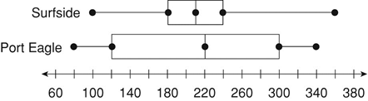

6. Which town has the greater median room price? _________________

7. Which town has the greater interquartile range of room prices? _________________

8. Which town appears to have more predictable room prices? Explain your answer.

9. If my budget for a nightly motel was $240, would I be better off finding a room in Surfside, or Port Eagle? Why?

Consider the following set of numbers:

20, 21, 21, 21, 28, 35, 43

Calculate the standard deviation for the set and draw a box-and-whisker for the set.

20 21 22 23 24 25 26 27 28 29 30 31 32 33 34 35 36 37 38 39 40 41 42 43

Compare the two central tendencies (box-and-whisker vs standard deviation). What does the standard deviation tell us about the set? What does the box and whisker tell us about the set? Name an advantage and disadvantage for each.

