Name ________________________________________ Sect __________________

8th grade: Measures of Central Tendencies – Test:

Q: What did the doctor say to the Invisible Man?
A: I’m sorry, you’ll have to come back later – I can’t see you right now.

Find the mean, median and mode for each of the following sets: (3 pts each)

8, 2, 1, 7, 8, 6, 9

Mean: Median: Mode:

9.8, 1.6, 7.2, 3.5, 1.6, 4.9, 7.2, 5.8

Mean: Median: Mode:

28, -12, 0, 33, -34, -11, 0, 3, 29

Mean: Median: Mode:

Make Box-and-Whisker Plots for the following sets: (4 pts each)

11, 12, 9, 7, 5, 18, 13:

Identify the following:

Median:
Lower quartile:
Upper quartile:
Low sample:
High sample:

______________________________________________________________________
0 1 2 3 4 5 6 7 8 9 10 11 12 13 14 15 16 17 18 19 20

5, 3, 2, 6, 4, 8, 3, 6, 16, 6:

Identify the following:

Median:
Lower quartile:
Upper quartile:
Low sample:
High sample:

______________________________________________________________________
0 1 2 3 4 5 6 7 8 9 10 11 12 13 14 15 16 17 18 19 20

Calculate the standard deviation for the following sets:

29, 31, 30, 29, 28, 33
Mean: Standard Deviation:

3, 16, 19, 2, 11, 21
Mean: Standard Deviation:

Compare the two standard deviations. In your own words, what do these numbers say about the two sets? (3 pts)

Complete the missing value: (3 pts)
A number set contains the following numbers: 21, 24, 18, 15, 20, 29, and x.
The mean of the set is 22. What is the value of x?

Calculate the mean of the following set. Identify the outlier, and then re-calculate without the outlier. (3 pts)

29, 97, 23, 31, 18, 24, 27

Mean:
Outlier:
Mean w/o outlier:

The following chart shows the number of pages in students’ research papers for all of the students in a 9th grade Social Studies class. Use the chart to determine the mean, median, and mode: (4 pts)

x x
x x x
x x x x
x x x x x x x x x
x x x x x x x x x x x x
2 3 4 5 6 7 8 9 10 11 12 13 14 15 16 17 18

Three different companies are in the business of selling stocks. The box and whisker plot below shows the number of stocks sold by employees at each of the companies. Use this graph to answer the questions below. Explain all answers. (1 pt each question)

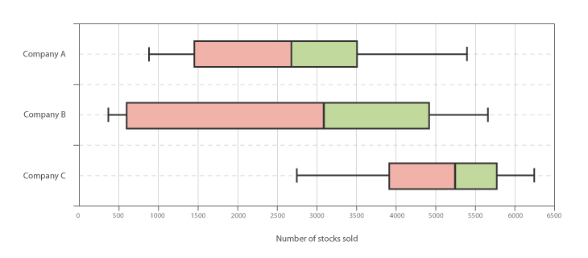

Which company has the highest median number of stocks sold? _________________

Which company has the smallest interquartile range? ______________________________

An investor wants to invest in one of these three companies. He is looking to invest in a company whose employees all consistently sell the same amount of stocks? What company would the investor LEAST likely want to invest. Why?

_______________________________________________________________________

_____________________________________________________________________

The President of company B is set to receive a large bonus payment if at least half of his employees sell 2500 stocks. Based on the data in the box-and-whisker plot, did he receive his bonus? How can you tell? ___________ _______________________________

______________________________________________________________________

______________________________________________________________________

Word Problem: (2 points)

Football University wants to recruit linemen who weigh at least 300 lbs. They are planning recruiting visits to two high schools. High School A has players with a mean average weight of 260 lbs and a standard deviation of 35.2. High School B has a mean average weight of 270 lbs and a standard deviation of 8.5.

Explain what high school is more likely to have players that weigh at least 300 lbs.

