Name ________________________________________ Sect _____________________
HW:
A snail crawls across the floor at a constant rate of 10 inches over 20 minutes. Use this information to answer the following questions below:
What is the x variable? _________________________
What is the y variable? _____________________________
What is the constant rate? ____________________________
Using your x and y variables and constant rate, write an equation to represent this scenario:
_________________________________

Complete the table below: Use the table to complete the graph:
x y
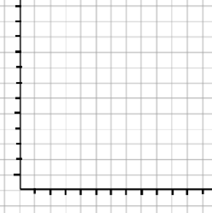

Pick any two points from the graph and use them to calculate the slope of the line in the graph. Show your work:

What do you notice about the slope and constant rate?
A redwood tree grows at a constant rate of 30 inches over 10 years. Use this information to answer the following questions below.

What is the x variable? _________________________
What is the y variable? _____________________________
What is the constant rate? ____________________________
Using your x and y variables and constant rate, write an equation to represent this scenario:
_________________________________

Complete the table below: Use the table to complete the graph:
x y

Pick any two points from the graph and use them to calculate the slope of the line in the graph. Show your work.

What do you notice about the slope and constant rate?

