Name ___________________________________ Sect ________________________
Use each table to write an equation:
Then use the points to draw a graph.

X Y X Y X Y
0 1 2 -2 1 3
1 2 1 -1 2 5
2 3 0 0 3 7
3 4 -1 1 4 9
4 5 -2 2 5 11

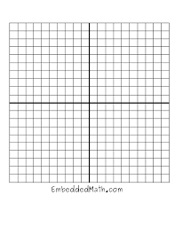
X Y
4 3
5 3.5
6 4
7 4.5
8 5

