Name ______________________________________ Sect _________________

Functions Unit Review

Make a table and a graph for each function

f (x) = -2x + 5 f (x) = -x – 4

X -2x + 5 Y X -x – 4 Y
0 0
1 2
2 4
3 6
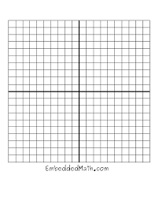
What is the domain of this function? What is the domain of this function?

What is the range of this function? What is the range of this function?

Identify which is a function and which is not a function: (2 pts each)

X Y X Y X Y X Y
3 0 1 -12 7 1 1 13
5 0 5 -8 -3 -5 3 ½
7 0 1 -12 1 2 1 13
9 0 7 -8 7 -1 3 - ½

Circle the linear functions from the equations below:

Y = 3x² y = 2x y = 5x³ – 12 y = 15 y = ½ x² – 9

A T-shirt manufacturer has a cost of $35 to set up for each batch of new T-shirts, plus he pays $4.50 per shirt. Write a linear function in the form y = mx + b to represent this relationship between cost and number of T-shirts made.

If he makes 65 T-shirts, how much total cost does he incur?
On the graph below, sketch the graph of the function with the rule f (x) = x² + 1 . Use the table to organize your work before you graph. (3 pts)

x | y
-3
-2
-1
0
1
2
3

Is this a linear function? Explain why or why not.

Nate walks to school. On Monday morning he leaves his house and starts walking. After getting halfway to school, he realizes he forgot his math homework and runs back home to get it. He then runs to school, stays at school until the end of the day, and then walks back home.

Which of the following graphs represents this function in terms of the relationship between time and Nate’s distance from home?

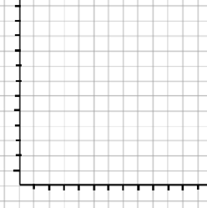

The following table represents the speed a train travels over time. Make a graph to represent the data shown in the table:

Time: 0 min 5 min 10 min 15 min 20 min 25 min
Speed: 0mph 60 mph 90 mph 30 mph 60 mph 0 mph

