Name ____________________________________________ Sect _________________
Intro to graphing quadratic equations: HW
Graph the following quadratic equations. Be sure to show at least 5 points. Show all work on back.

y = - x² – 3 y = 3x²
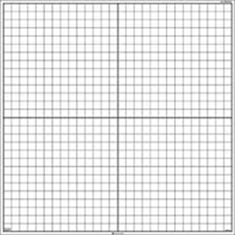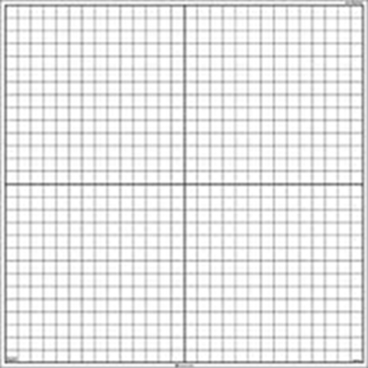

y = (x – 2)² y = (x + 3)²

