Name ____________________________________________ Sect _________________
Unit Review: Intro to quadratic equations and polynomials

Graphing quadratics:
Make a table and clearly label at least 5 points. Locate the vertex of the parabola. Show your work.
(3 pts each)

y = x² – 3 y = - x² + 6
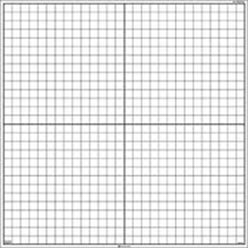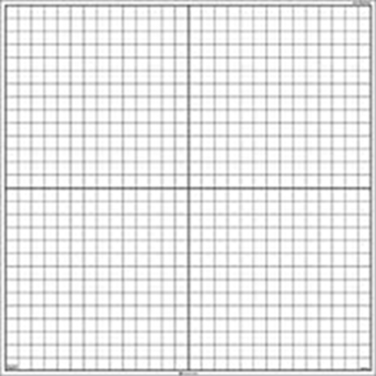

y = (x – 2)² + 1 y = - 2x² – 3

Multiply the following polynomials: (2 pts each)
x (x – 5) 2y (y + 1) 3z (z + 1 – a)

2 (-4q + 3s – 5) -2d (3d + 2f – 6) -6g (-3g + 2h – 5)

(m + 7)² (n – 7)² (p + 7) (p – 7)

(2d + 4) (d + 3) (3f – 6) (f + 2) (7g – 2) (2g – 3)

Factor the following polynomials: (2 pts each)
4b² + 6b 11c² + 33 27d² + 18d – 36df

220g² + 40fg – 60g 5s² – 25s – 40 - 13d² – 8cd – d

Word Problems: (2 pts each)
A rectangle has two sides that are represented by the expressions (2x + 5) and (x – 1). Write separate expressions for the area and perimeter.
Area: Perimeter:

A rectangle has an area represented by the expression 5x² + 15. If the length of one side is 20 inches, what is the length of the other side?

A rectangular patio has a width that is three times the length. If the area of the pizza is 192 square feet, what are the dimensions of the patio?

