Name __________________________________________ Sect __________________

Find the slopes of the following lines, graph, identify the y-intercept, and write a linear equation:

A line that passes through the points A line that passes through the points
(0, 2) (3, 5) (0, 6) (2, 8)

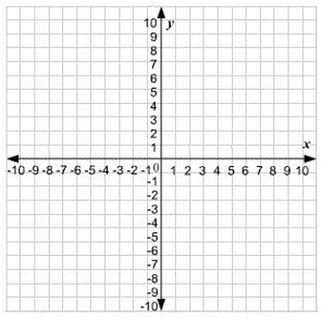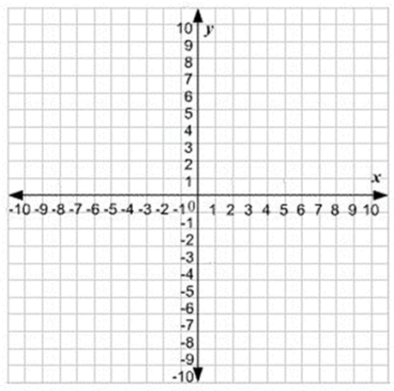

m = m =

Can you identify the y intercept? Can you identify the y intercept?
b = b =

Write an equation for this line in Write an equation for this line in
slope-intercept form (y = mx + b) slope-intercept form (y = mx + b)

A line that passes through the points A line that passes through the points
(0, 5) (2, 1) (-4, -2) (0, -10)

m = m =

Can you identify the y intercept? Can you identify the y intercept?
b = b =

Write an equation for this line in Write an equation for this line in
slope-intercept form (y = mx + b) slope-intercept form (y = mx + b)

