Name ____________________________________________ Sect ______________________
Linear Equations Make-up Test – 8th Grade
Identify the slope and y intercept from the following linear equations. Then graph: (3 pts each)

y = 3x + 1 y = - $\frac{3}{4}$ x - 2

m = _______ m = _______

b = _______ b = _______

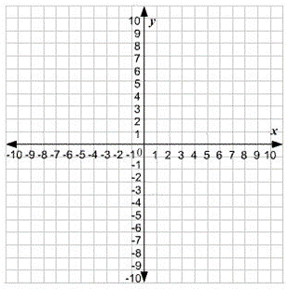

Write a linear equation and graph a line that passes through the two indicated points. (4 pts each)

(0, 5) (2, 9) (-1, 2) (2, -7)

m = ___________ m = __________

b = ____________ b = __________

Equation: Equation:

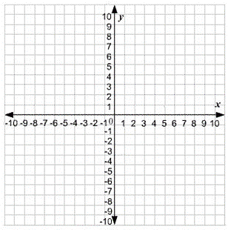

Identify the slope and y-intercept of the following equations. Write the linear equation in slope-intercept form and then graph the line that is represented by the equations. (4 pts each)

y – 4 = 3x 6x + 3y = 18

Equation: (slope-intercept form) Equation: (slope-intercept form)

___________________ ________________________

m = ____________ m = ____________

b = ____________ b = ____________

Answer the following questions based on the information given: (4 pts)

Nate is a college student who needs college credits to graduate. After completing 2 semesters, he needs 90 more credits to graduate. After completing 5 semesters he needs 45 more credits to graduate.

If x = semesters completed, and y = remaining credits, calculate the slope of the line that represents this scenario:

__________________________________________

What is the y-intercept?

__________________________________________

Write a linear equation for this scenario.

___________________________________________

Graph what this equation would look like:

Credits
Semesters

After how many semesters would he have no remaining credits?

________________________________________________

