Name ____________________________________________ Sect ______________________
Linear Equations Review – 8th Grade

Graph a line with through the indicated points with the slopes given.

m = 3 m = - $\frac{3}{4}$ m = 0

Identify the slope and y intercept from the following linear equations. Then graph:

y = 3x +1 y = -$\frac{5}{4}$ x + 3 y = $\frac{1}{2}$ x - 7

m = _______ m = _______ m = _______

b = _______ b = _______ b = _______

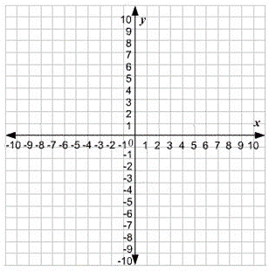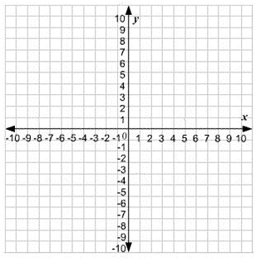

Write a linear equation and graph a line that passes through the two indicated points.

(0, 2) (5, 7) (3, 5) (0, -1)

Equation: Equation:

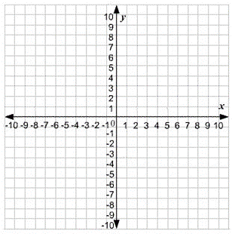

(3, 1) (-6, -5) (-2, -4) (1, 8)

Equation: Equation:

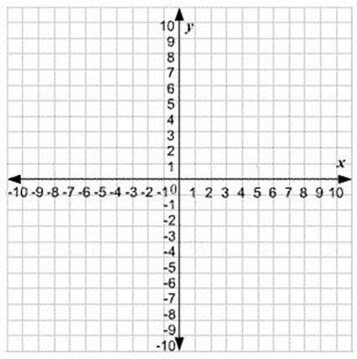

Identify the slope and y-intercept of the following equations. Write the linear equation and then graph the line that is represented by the equations.

2y + 6x = 12 2 (y – 3) = 6x y – 4x = -y + 10

Answer the following questions based on the information given:

The Mountain City Gazette charges a subscription fee of $30/month plus $10 for every week the newspaper is delivered. This is represented by the linear equation y = 30x + 10, with x = weeks delivered and y = $. Draw a graph of what this linear equation would look like.

What is the y-intercept of this line?

What is the slope of this line?

How much would the newspaper charge if it was delivered for two weeks?

How many weeks would the newspaper be delivered if the fees were $70?

Mick earns money for keeping stats at his high school basketball games. He gets paid a fixed monthly fee for his services plus additional money for every game he works. In January he worked 7 games and earned $60. In February he worked 9 games and earned $70.

If x = games and y = $, calculate the slope of the line that represents this scenario:

__________________________________________

What is the y-intercept?

__________________________________________

Write a linear equation for this scenario.

___________________________________________

Graph what this equation would look like:

If Mick worked 12 games in a month how much would he make?

________________________________________________

