Name __________________________________________ Sect __________________

Linear Equations: Review.

Find the slope of each line:

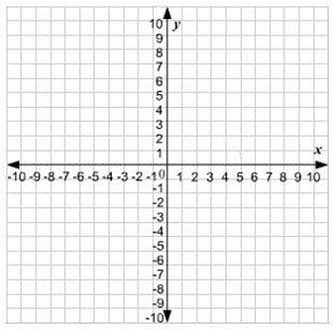

m = _________ m = __________

Find the slope of a line that passes through the points,

(1, 7) (3, -2) (-10, 4) (-5, -6)

m = ______________ m = ___________

Draw a line through the given point with the given slope.

(5, 2); m = -2 (-6, -9) ; m = $\frac{1}{3}$

Identify the slope and y-intercept from the following equations. Then graph the equations.

y = -4x + 8 y = $\frac{3}{2} x-5$

m = ___________ m = ____________

b = ___________ b = ____________

Put the following equations into slope-intercept format. Identify the slope and y-intercept. Then graph the equations.

-12x – 3y = -6 -5x + 10 y = 15

Equation = ___________________ Equation = _________________

m = ___________ m = __________

b = ___________ b = ___________

Based on the following graphs below, write a linear equation in slope-intercept form for each graph

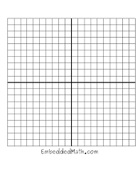
m = ___________________ m = __________________

b = ____________________ b = ___________________

equation = __________________ equation = _________________

Write a linear equation for a line that goes through the points listed. Identify the slope and y-intercept. Then graph the equation.

(0, 3) (4, -1) (0, 2) (-8, -14)

m = ________ m = _________

b = ________ b = _________

equation = __________________ equation = __________________

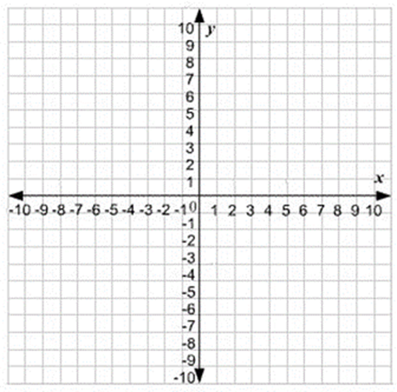

Continued next page

(-8, 2) (4, -4) (10, -2) (-5, 1)

m = ________ m = _________

b = ________ b = _________

equation = ___________________ equation = __________________

Joey swims at a constant rate. After 30 minutes, he has swam 75 laps. Write an equation for this scenario, identify the slope and y-intercept, and graph the line for this equation. Be sure to label your x and y axis with units, and identify the scale of your graph.

m = ____________ b = _____________ Equation = ___________________

Using the equation from above, how many laps would Joey have swam after 50 minutes. Show your work.

