Name __________________________________ Sect ______________________
Rates and Proportions Review:
Find the unit rate:

1,500 miles 1,440 yards 32 pets
50 days 12 games 48 families

A bike rider averages a speed of 18 miles per hour. If the bike rider rides for 7.5 hours, how far will he have travelled?

Terrence reads 87 pages while reading for 3 hours. What is his average pages per hour?

Are the following rates proportional? Show your work.

$\frac{3}{5} \frac{12}{15}$ $\frac{11}{33} \frac{22}{55}$

Complete the missing variables.

$\frac{x}{9}=\frac{8}{36}$ $\frac{4}{14}= \frac{12}{p}$

Are the following shapes similar figures?

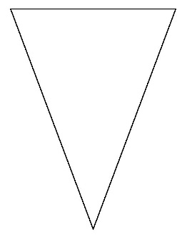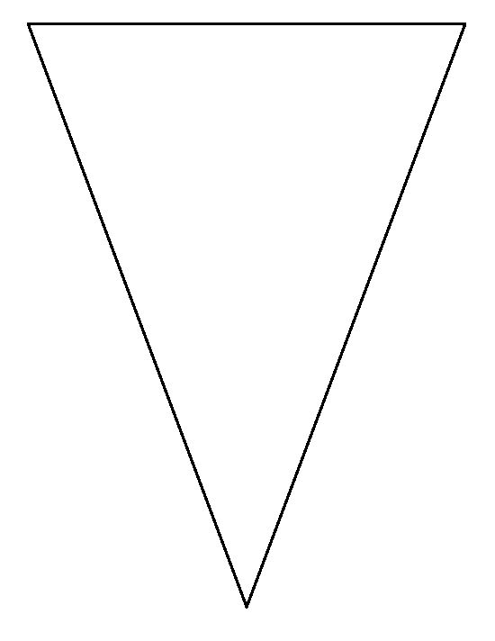

The following shapes are similar. Find the length of the missing sides.

Identify the corresponding sides and angles:

Angle X corresponds to ______________

Angle Y corresponds to ______________

Angle Z corresponds to ______________

Side YZ corresponds to ______________

Word Problem:
The Smiths’ living room measures 18’ wide x 30’ long. They want to buy a carpet that will be similar in shape to the room. If the new carpet measures 15’ w, then how long will the carpet be?

