Name _________________________________________ Sect ______________________
Find the lengths of the missing hypotenuses.

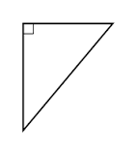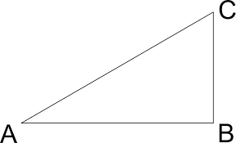

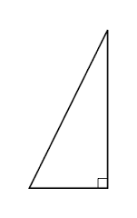

A baseball diamond is a square with sides measuring 90 feet. What is the straight across distance from 1st base to third base? (Hint: Draw a picture to make sense of the problem)

