Name _________________________________________ Sect ______________________
Find the lengths of the missing legs.

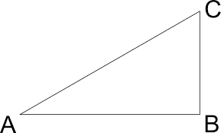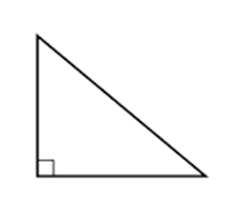

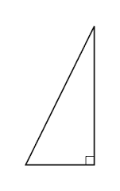
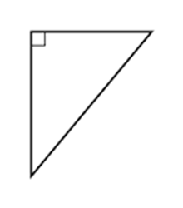
Tyler has a ramp for his skateboard that measures 17 feet long. The vertical height is 8 feet from the ground to the top of the ramp. What is the horizontal distance from the base of the ramp to the support? (Hint: draw a picture)

