Name Date

Practice A

7.3

Find the missing length of the triangle.

1. 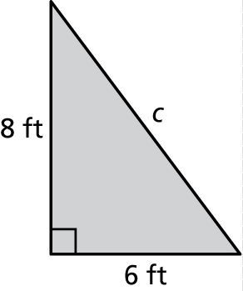 2. 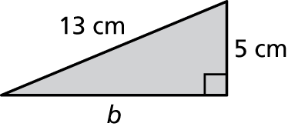

3. 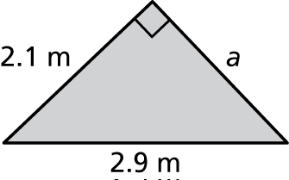 4. 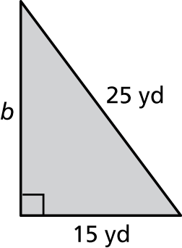

5. 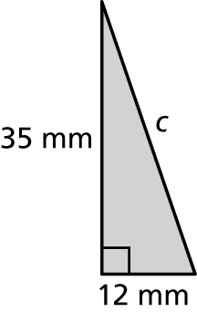 6. 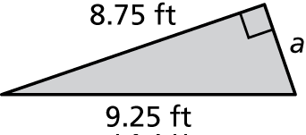

7. 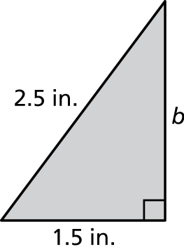 8. 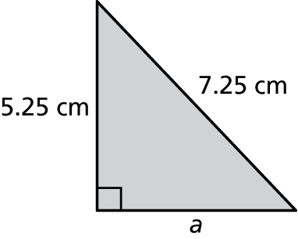

9. Laptops are advertised by the lengths of the diagonals of the screen. You purchase a 15-inch laptop and the width of the screen is 12 inches. What   
is the height of its screen?

5. A small shelf sits on two braces that are in the shape of a right triangle.   
The leg (brace) attached to the wall is 4.5 inches and the hypotenuse is   
7.5 inches. The leg holding the shelf is the same length as the width of   
the shelf. What is the width of the shelf?

8. Can a right triangle have a leg that is 10 meters long and a hypotenuse   
that is 10 meters long? Explain.

9. One leg of a right triangular piece of land has a length of 24 yards.   
The hypotenuse has a length of 74 yards. The other leg has a length   
of 10*x* yards. What is the value of *x*?

Name Date

Practice B

7.3

Using the Pythagorean Theorem

Find the missing length of the figure.

1. 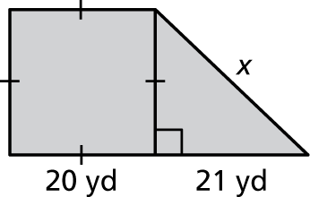 2. 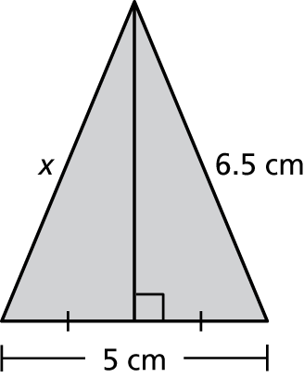

3. You built braces in the shape of a right triangle to hold your surfboard. The leg (brace) attached to the wall is 10 inches and your surfboard sits on a leg that is 24 inches. What is the length of the hypotenuse that completes the right triangle?

4. In a right isosceles triangle, the lengths of both legs 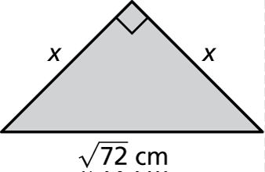are equal. For the given isosceles triangle, what is   
the value of *x*?

5. To get from your house to your school, you ride your 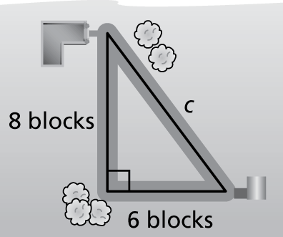bicycle 6 blocks west and 8 blocks north. A new road is being built that will go directly from your house to your school, creating a right triangle. When you take the new road to school, how many fewer blocks will you be riding to school and back?