Name _________________________________________ Sect ______________________
Are the following triangles right triangles? Show your work.

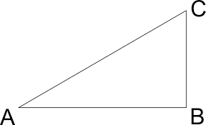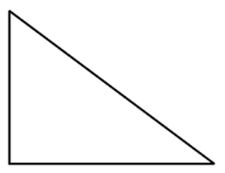

Maria is installing a window in her house. The window is a perfect rectangle and measures 2.5’ x 6’. She cuts a hole in her wall to these dimensions, but she wants to make sure her angles are right angles. She measures diagonally from corner to corner and it measures 6.75’. Does her rectangle have right angles? Explain and show your work.

