Name _________________________________________ Sect ______________________

Solve for the missing sides:

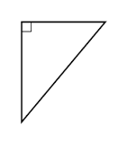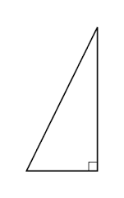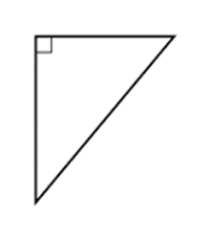

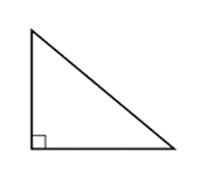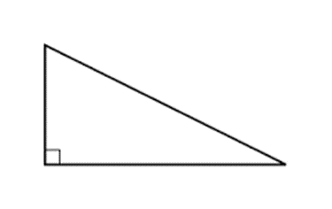

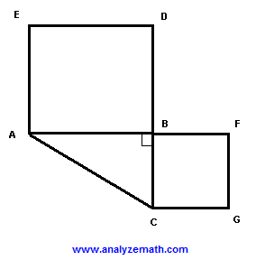

In the above picture, line segment AC measures 12.5 cm long. Square BCGF has an area of 12.25 sq cm. Calculate the area of square ABDE. Use what you know about area and the Pythagorean Theorem to solve.

Graph the points indicated. Then find the distance between the points. (3 pts each)

(9,8) (1, -7)
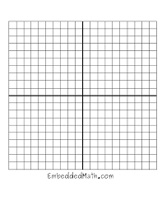

(-8, -7) (1, 5)
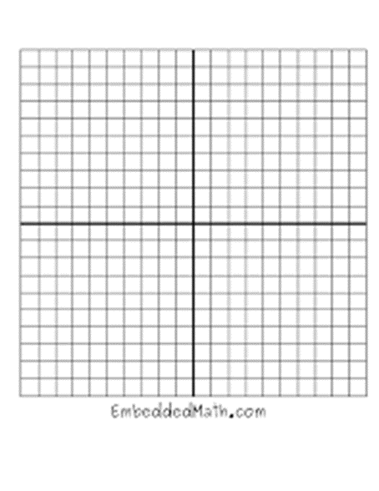

The landing outside the library doors measures 6 ft above the ground. There is an access ramp to the landing, with the base of the ramp set 17.5 feet out from the landing. What is the length of the ramp?

Jimmy builds sets for the school play. A backdrop for one scene measures 2.4 meters tall. In order to stabilze the backdrop, he builds a diagonal brace to support it. The brace measures 2.6 meters long. Assuming he wants the backdrop to be perfectly perpindicular to the ground, how far out from the backdrop should the brace be set?

The Dorfmeyers’ backyard measures is a rectangle that measures 7 yards x 11.25 yards. Mrs. Dorfmeyer wants to hang a clothesline diagonally across the yard from one corner to the opposite corner. How long a rope will she need to hang this clothesline?

Proofs – Show whether or not the following are right triangles. (3 pts each)

