Name ____________________________________________ Sect ___________________
Reflection – A rigid motion that flips a figure over a line known as the line of reflection. Also known as a “flip”

Graph and draw the following figures based on the coordinates given. Then graph the reflection as indicated and label the new points.

A square with the points (-4, 5), (-3, 2), (-1, 6) and (0, 3)
Reflect across the y-axis.
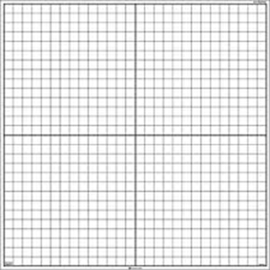
A triangle with the points (-3, -4), (0, -2), and (2, -4)
Reflect across the x axis.
A parallelogram with the points (-5, 4), (-4, 2), (-1, 4) and (0, 2)
Reflect across the x axis.
A quadrilateral with the points (6, 0), (5, 4), (2, 7) and (1, -1)
Reflect across the y axis.

