Name ____________________________________________ Sect ___________________
Rotation – A rigid motion turns a figure about a fixed point called the center of rotation.

Graph and draw the following figures based on the coordinates given. Then graph the rotation as indicated and label the new points.

A triangle with the points (5, 0), (3, 4) and (2, 0)
Rotate 180° about the origin
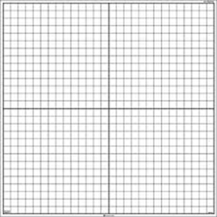
A quadrilateral with points (-4, -3),( -3, -1), (-1, -5), and (1, -2)
Rotate 90° about the origin
A triangle with points (-7, -6), (-7, -2) and (-1, -4)
Rotate 270° about the origin.
A quadrilateral with the points (6, -5), (4, 1), (2, 0) and (1, -8)
Rotate 180° about the origin

