Name Date

Practice A

10.7

Find the sum or difference. Write your answer in scientific notation.

1.  2. 

3.  4. 

5.  6. 

Find the product or quotient. Write your answer in scientific notation.

7.  8. 

9.  10. 

11.  12. 

13.  14. 

Find the area of the figure. Write your answer in scientific notation.

15. 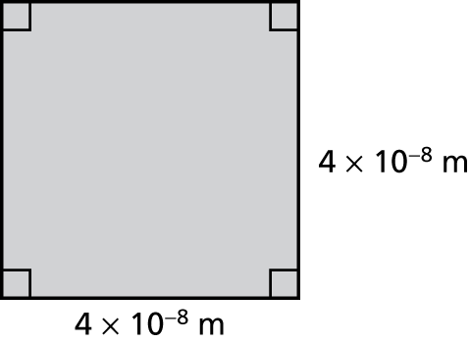 16. 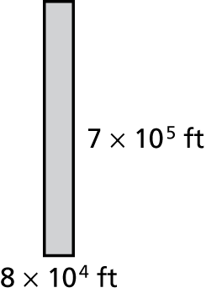

17. The table shows the volumes of the three largest giant sequoia trees. Which tree has the greatest volume? How much greater is its volume than each of the other two trees?

|  |  |
| --- | --- |
| Tree Name | Volume (cubic feet) |
| General Grant |  |
| General Sherman |  |
| Washington |  |

Name Date

Practice B

10.7

Find the sum or difference. Write your answer in scientific notation.

1.  2. 

3.  4. 

Find the product or quotient. Write your answer in scientific notation.

5.  6. 

7.  8. 

9.  10. 

11.  12. 

13.  14. 

Find the area of the figure. Write your answer in scientific notation.

15. 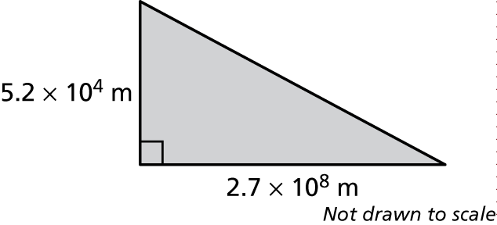 16. 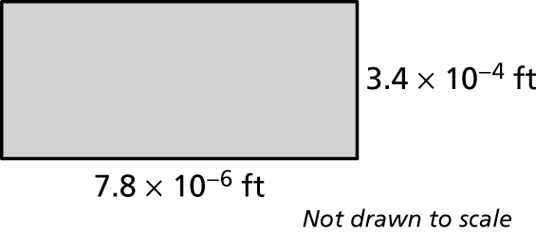

17. How many times greater is the total area of Russia than the total area   
of Finland?

