Name ___________________________________________ Sect _______________________

Use the graphing method to solve the following system of linear equations:

y = -2x – 1
y = x + 8 Solution: _________________

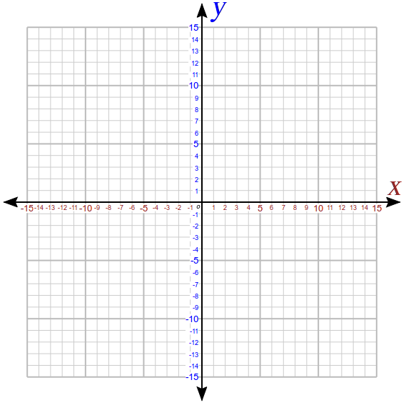

Use the substitution method to solve the following system:

y = x + 2
y = 3x – 2 Solution : _________________

Use the elimination method to solve the following systems:

3x – y = 1
2x + y = 9 Solution: __________________

3x – y = 10
3x + 2y = 7 Solution : _________________

2x – y = -3
6x + 2y = 16 Solution: ___________________

Solve the following systems using whatever method you prefer. A graph is included on the page if you choose to use the graphing method:

y = x – 1 2x + 2y = 6 y = 2x – 11
2y = x + 3 3x – y = 13 3x + y = -1

Solution : ________ Solution : ________ Solution : ________

