Name ___________________________________________ Sect _______________________

8th Gr: Linear Systems Review
Tell whether each system of linear equations has one solution, no solution, or infinite solutions (1 pt each)

Y = 3x – 4
Y = 3x + 2 ________________

Y = 5x – 3
Y = 3x – 5 ________________

Y = -9x + 2
Y = 9x – 2 _________________

Y = 4x + 8
-8x + 2y = 16 __________________

3x + 6y = 12
Y = ½ x – 5 __________________

Show whether the order pair is or isn’t a solution to the system of linear equations
(2 pts each)

(1, 9) ____________ (11, 2) ____________

Y = 2x + 7 y = x – 9
Y = 10x – 1 2x + 2y = 25

Use the graphing method to solve the following system of linear equations:
(3 pts)
y = ½ x + 2
y = 2x – 10 Solution: _________________

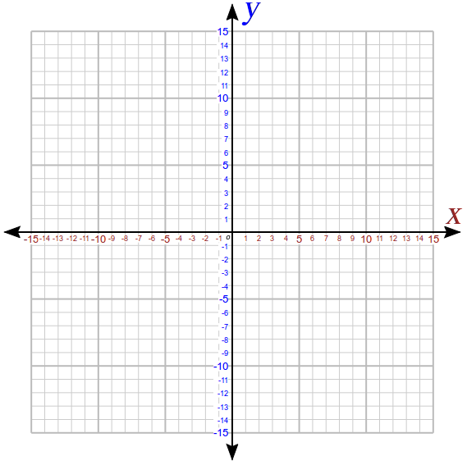

Use the substitution method to solve the following systems: (3 pts each)

y = x – 7
y = 3x – 17 Solution : _________________

Y = 2x + 8
-5x + y = 5 Solution : _________________

Use the elimination method to solve the following systems: (3 pts each)

x + 3y = 16
2x – 3y = 14 Solution: __________________

2x + 2y = 8
2x + 5y = 26 Solution : _________________

3x + y = 23
x – 2y = -18 Solution: ___________________

Solve the following systems using whatever method you prefer. Use the word problems to write linear equations, and then solve the systems using whatever method you prefer. Be sure to show all work. A graph is included on the page if you choose to use the graphing method: (4 pts each)

Two tanks of water are being emptied at different rates. The first tank holds 12 gallons, and is being emptied at a rate of 2 gallons per minute. The second tank holds 8 gallons, but is being emptied at a rate of ½ gallon per minute. After how many minutes will the two tanks have the same amount of water?

1st tank equation : ______________________

2nd tank equation : ______________________

Solution : _____________________________

Mr. Rich has a total of $135, consisting of all either $20 bills or $1 bills. He has a total of 21 bills. How many $20 and how many $1 bills does he have ?

Identify your variables :

X = ____________
Y = ____________

Write your equations :

________________________

________________________

Solution : ___________________

