Name ____________________________________________ Sect ___________________
Translation – A rigid motion that moves every point of a figure the same distance and the same direction. Also referred to as a “slide”

Graph and draw the following figures based on the coordinates given. Then graph the translation as indicated and label the new points.

A rectangle with the points (2, 6), (2, 1), (5, 6), (5, 1).
Translate 3 units to the right, and 2 units up.
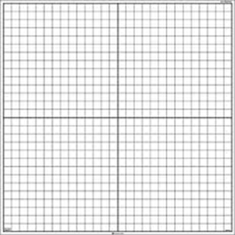
A triangle with the points (-1, 4), (-4, 2) and (3, 0)
Translate 2 units to the left, and 4 units down.
A trapezoid with the points (3, -1), (6, -1), (2, 3) and (6, 3)
Translate based on the rule (x – 2), (y + 1)
A triangle with the points (-2, -4), (-1, -1), and (0, -5)
Translate based on the rule (x ˗ 3), (y – 4)

