Name ________________________________________ Sect __________________

A standard soda can holds 355 cubic centimeters of liquid. If the can measures 13 cm tall, what is the radius of the lid?

Toblerone Chocolate is known for its unique packaging, shaped like a triangular prism as shown. If a package can hold 15.588 cubic inches of chocolate, and the base of the triangle measures 2 inches and the length of the package is 9 inches, what is the height of triangular face? Round answer to nearest 100th.

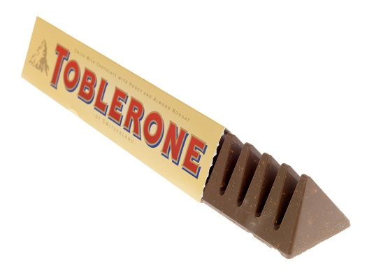
Identify the shape of the solid and solve for the volume:

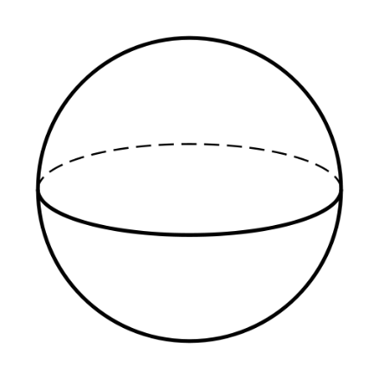

Figure: ________________ Figure: _________________ Figure: _______________

Vol: Vol: Vol:

Composite Volumes:
Find the volume of the composite solids:

