Name Date

Practice A

10.6

Write the number in scientific notation.

1. 350,000 2. 0.0004

3. 0.000000000000527 4. 12,500,000

5. 1,900,000,000 6. 0.0000001

7. 5,000,000,000,000 8. 0.00006524

Order the numbers from least to greatest.

9.  10. 

11.  12. 

13. The number of stars in the Milky Way Galaxy has been approximated to be between 200 billion and 400 billion. Write these numbers in scientific notation.

14. The ångström is a unit of length defined to be 0.1 nanometer or 0.0000000001 meter. Write this number in scientific notation.

15. In 2013, the net worth of a businessman was $59,000,000,000.

a. Write $59,000,000,000 in scientific notation.

b. As of 2012, the businessman had given over $28,000,000,000 to charity. Write $28,000,000,000 in scientific notation.

c. In 2002, the businessman’s wealth briefly surpassed $101,000,000,000. Write $101,000,000,000 in scientific notation.

16. A pipette is a laboratory instrument that is used to transport a measured volume of liquid. A pipette that dispenses between 1 and 1000 microliters is called a micropipette.

a. A microliter is equivalent to 0.000001 liter. Write 0.000001 in scientific notation.

b. One thousand microliters is equivalent to 0.001 liter. Write 0.001 in scientific notation.

Order the numbers from least to greatest.

17.  18. 

Name Date

Practice B

10.6

Write the number in scientific notation.

1. 0.000085 2. 410,000,000

3. 0.0143 4. 134,750,000,000

5. 7,000,000,000,000,000 6. 0.00000000000199

7. 52,400,000,000,000 8. 0.00000006133

Order the numbers from least to greatest.

9.  10. 

11.  12. 

13. The atomic mass of carbon-12 is 0.00000000000000000000001992 kilogram. Write this number in scientific notation.

14. Approximately how many moons 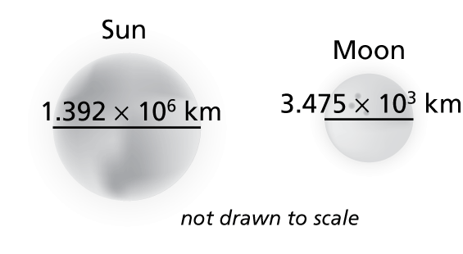  
would be needed side-by-side to   
span across the Sun?

15. Most golf balls have about 250 to 450 dimples. The record holder is a ball with 1070 dimples.

a. Write 1070 in scientific notation.

b. In a recent year, it was estimated that 540,000,000 golf balls were sold. Using an average of 350 dimples, how many dimples were on the golf balls sold in that year? Write your answer in scientific notation.

16. The population of a country is about 6,940,000.

1. Write 6,940,000 in scientific notation.
2. There are about 17,251 people per square mile in the country. What is the area of the country (in square miles)? Round your answer to the nearest whole number.

Order the numbers from least to greatest.

17.  18. 