Name ________________________________________ Sect _______________
Graphing real-life functions
Use the tables below to graph functions. Be sure to label and your axis and show scale.
Day # of students in class Month Price of gallon of gas
Mon 27 Jan $2.40
Tues 27 Feb $2.20
Wed 25 March $2.00
Thurs 30 April $1.80
Fri 30 May $2.50
Next Mon 30 June $2.50
Next Tues 25 July $2.80
Next Wed 20 August $2.80
Next Thurs 20 Sept $3.00
Next Fri 28 Oct $2.50

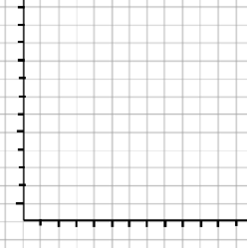

Based on the situations described, draw a graph to represent the function. Be sure to label your graph and axis.
Graph A: In January, the average daily temperature is 35 degrees. The average temperature increases 10 degrees per month until May. From May to July the average temperature increases by 5 degrees per day. The average temperature stays the same through September. From September through December the average temperature decreases by 15 degrees per month.

Graph B: An airplane takes off from ground level and climbs to cruising altitude. After leveling off for a period of time, the plane needs to climb to a higher altitude to avoid turbulence. The plane then cruises at the new altitude for a period. It then descends slowly before landing back at ground level.

Graph A Graph B

