Name ____________________________________________ Sect ___________________
Do Now: Intro to Rigid Motions

On the graph below, correctly plot the following four coordinates:

(2, 6), (2, -4), (-1, -4) and (-1, 6)

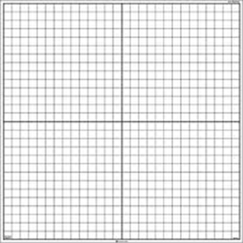

What shape did you create? ___________________________

What are the dimensions of the shape?
__________________________________________________

What is the area of the shape?

__________________________________________________

On the same graph above, draw another shape in a different location on the graph with the same dimensions.

Identify the new coordinates (ordered pairs) for the corners of the new shape you just drew:
_____________________________________________________

