Name _________________________________________ Sect _______________
Lines of Best Fit:

Create a scatterplot using the following data. Once you have completed the scatterplot, draw a line of Best Fit.
Then use what you know about writing linear equations (think slope and y-intercept) to write an equation for the line of Best Fit.

Number of Hours: 1 2 3 4 5 6 7
Miles Driven: 30 58 90 119 155 185 210

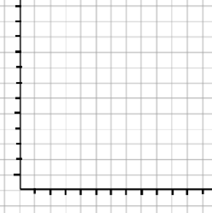

Equation:

Now use the equation to predict how many miles you will have driven after 11 hours.

Create a scatterplot using the following data. Once you have completed the scatterplot, draw a line of Best Fit.
Then use what you know about writing linear equations (think slope and y-intercept) to write an equation for the line of Best Fit.

# of Months: 1 2 3 4 5 6 7
Money in bank: $950 800 700 650 1,200 425 300

Is there an outlier? Which set of data?

Equation:

Now use the equation to predict how much money you will have after 9 months.

