Name ________________________________________ Sect _____________________
M3 L4 Do Now

On the graph below, draw a triangle with the points (0, 0), (3, 0), and (0, 4). Label this triangle ABC.

Now dilate it with a scale factor of 3. What are the new coordinates? Graph the dilated image. Label this triangle A₁ B₁ C₁

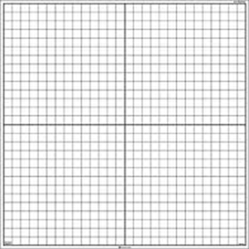

If the angles of triangle ABC measure 90⁰, 37⁰, and 53⁰, what do the angles of the new dilated triangle A₁ B₁ C₁ measure?

