Name __________________________________ Sect _________________
M3 L6 Do Now
On the graph below, draw a triangle with the coordinates (-4, 0), (-2, 0) and (-3, 5). Apply a scale factor of 2. Identify the new coordinates and graph the new image.

New coordinates:

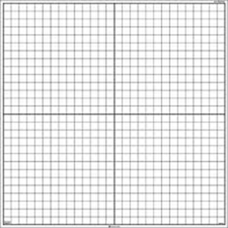

On the graph below draw triangle LMN with the coordinates (6, 9), (3, 12), and (-6, 9).

Draw its dilated image with the coordinates (2, 3), (1, 4) and (-2, 3)

Did you magnify the original figure or shrink it?

Do you have enough information to identify the scale factor? How would you use the information given to identify the scale factor? Show how you would solve.

