Name __________________________________ Sect _______________

Problem Set M3 L7 do now

1. Triangle $ABC$ is shown on the coordinate plane below. The triangle is dilated from the origin by scale factor $r=4$. Identify the coordinates of the dilated triangle .

Macintosh HD:Users:shassan:Desktop:ps1.pdf

1. Triangle is shown on the coordinate plane below. The triangle is dilated from the origin by scale factor $r=\frac{5}{4}$. Identify the coordinates of the dilated triangle $A'B'C'$.

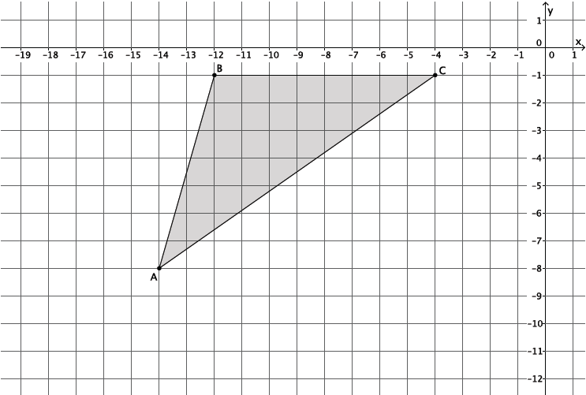

1. The triangle $ABC$ has coordinates $A\left(6, 1\right)$, $B(12, 4)$, and $C(-6, 2)$. The triangle is dilated from the origin by a scale factor $r=\frac{1}{2}$. Identify the coordinates of the dilated triangle $A'B'C'$.
2. Figure $DEFG$ is shown on the coordinate plane below. The figure is dilated from the origin by scale factor $r=\frac{3}{2}$. Identify the coordinates of the dilated figure $D^{'}E^{'}F^{'}G^{'}$, and then draw and label figure $D^{'}E^{'}F^{'}G^{'}$ on the coordinate plane.

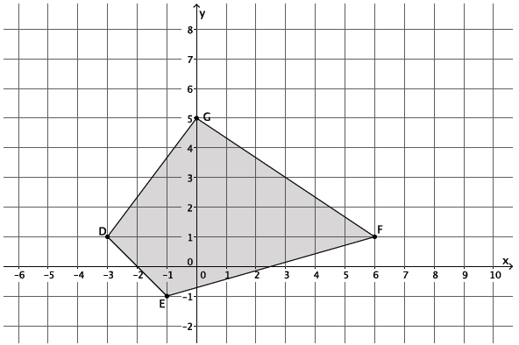

1. Figure $DEFG$ has coordinates $D\left(1, 1\right)$, $E\left(7, 3\right)$, $F(5, -4)$, and $G(-1, -4)$. The figure is dilated from the origin by scale factor $r=7$. Identify the coordinates of the dilated figure $D^{'}E^{'}F^{'}G^{'}$.