Name _________________________________________ Sect _______________
M3 L8 HW
Problem Set

- In the picture below, we have triangle $DEF$ that has been dilated from center $O$ by scale factor $r=4$. It is noted by $D'E'F'$. We also have triangle $D''E''F''$, which is congruent to triangle $D'E'F'$ (i.e., $△D'E'F'≅△D''E''F''$). Describe the sequence of a dilation, followed by a congruence (of one or more rigid motions ), that would map triangle $D''E''F''$ onto triangle $DEF$.

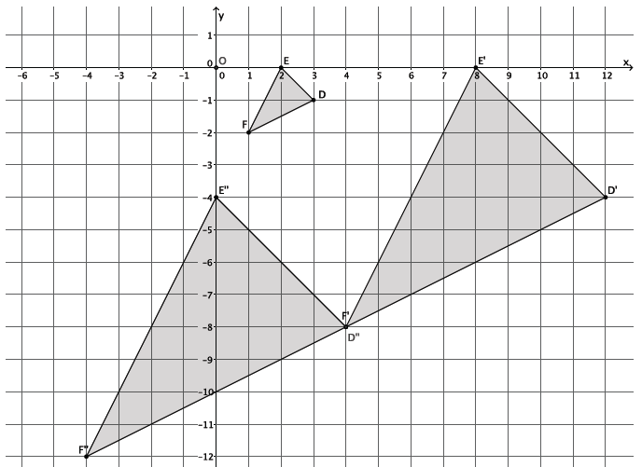

- Triangle $ABC$ was dilated from center $O$ by scale factor $r=\frac{1}{2}$. The dilated triangle is noted by $A'B'C'$. Another triangle $A''B''C''$ is congruent to triangle $A'B'C'$ (i.e., $△A''B''C''≅△A'B'C'$). Describe the dilation followed by the basic rigid motions that would map triangle $A''B''C''$ onto triangle $ABC$

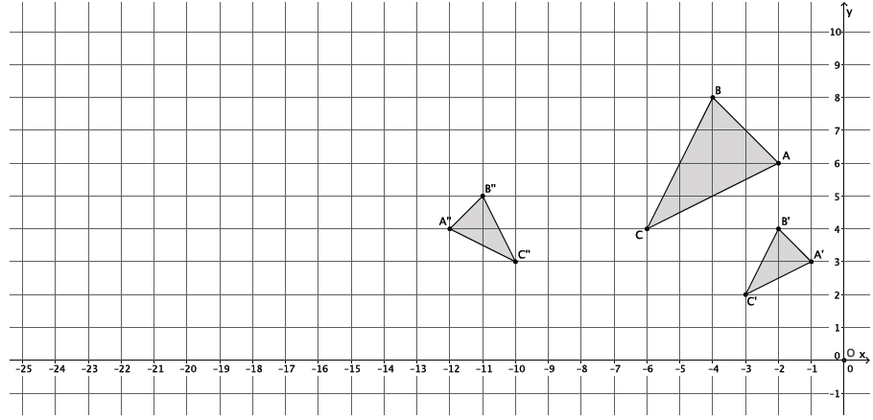

- Are the two figures shown below similar? If so, describe a sequence that would prove the similarity. If not, state how you know they are not similar.
