Name _______________________________________ Sect ________________
L11 Do Now:
The following table and graph show the total amount of pancakes that Billy and Willy could eat over the course of an hour. Both eat their pancakes at a constant rate. Use the table and graph to answer the questions below.
Billy:
Minutes: 10 20 30 40 50 60
Pancakes: 1 2 3 4 5 6

Willy:
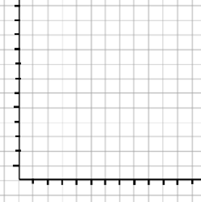
After how many minutes did Willy start eating his pancakes?

Who ate their pancakes at a faster rate?

After how many minutes had they eaten the same number of pancakes?

If Billy continued eating pancakes at a constant rate, how many pancakes would he have eaten after 125 minutes?

