Name _________________________________________ Sect _______________
M4 L16 HW

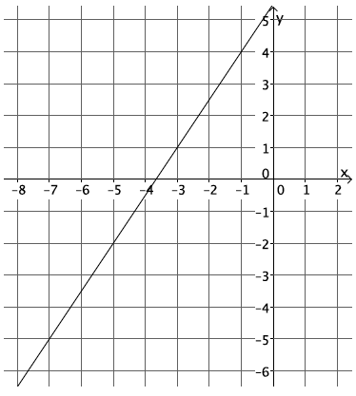
- Calculate the slope of the line using two different pairs of points.
  - Select any two points on the line to compute the slope.
  - Select two different points on the line to calculate the slope.
  - What do you notice about your answers in parts (a) and (b)? Explain.

- Calculate the slope of the line in the graph below.

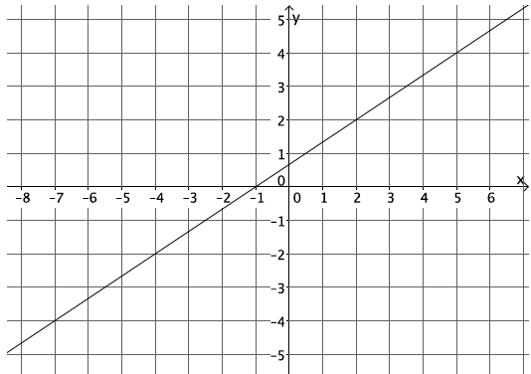

- Your teacher tells you that a line goes through the points $\left(-6, 1\right)$ and $(-4, 3)$.
  - Calculate the slope of this line.
  - Do you think the slope will be the same if the order of the points is reversed? Verify by calculating the slope, and explain your result.

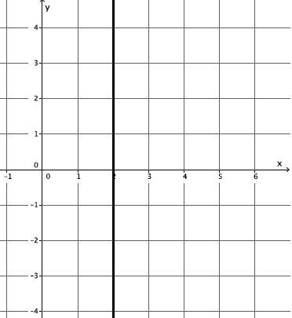
- Each of the lines in the lesson was non-vertical. Consider the slope of a vertical line, $x=2$. Select two points on the line to calculate slope. Based on your answer, why do you think the topic of slope focuses only on non-vertical lines?

