Name ___________________________________________ Sect ___________

Systems Graphing: Exit Ticket:

On the graph below, carefully graph both equations.

y = 5x - 9 y = $-\frac{1}{2}$ x + 2

m = _________ m = ___________

b = _________ b = ____________

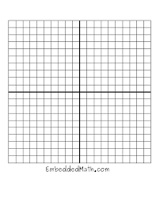

Using the graph, can you identify the point where the two lines intersect?

How can you check to verify that this point satisfies both equations?