Name ________________________________________ Sect ____8__________________ Weekly Math Maintenance # 25
Graph a line for the equation  y = $-\frac{1}{3}$ x + 7  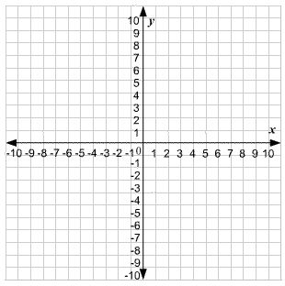 | Graph a line that passes through the point (8, 4) with a slope of 4.  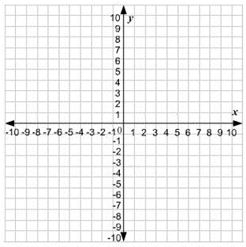 | What is the surface area of the following prism?  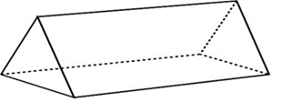 | Scrambled: Use all four of the number set to create the first number. You must use each number once and only once, and you can use any combination of the four basic operations (+, -, x, ÷)  64: 3, 4, 6, 8
What is the equation for a line that passes through the following points:  (5, 9) (0, -1) | Are these two triangles similar? Show or explain.  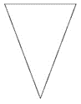 | If angle 2 measures 55 ͦ, what is the measure of angle 7?  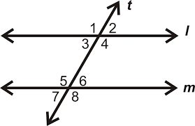 | The cost of renting a boat the lake is $20/hour plus $12 for each life jacket. The total cost is represented by the equation c = 20h + 12, where c is total cost and h is the number of hours. How much does it cost to rent a boat for 3.5 hours?
$$>, <, or=$$  .55 _____ $\frac{5}{9}$ | Determine whether the ordered pair (3, 11) is a solution to the equation  y = 4x - 1 | Solve for y:  7.2 = -.9y | A health club charges $100 to join and $25 per month. There is also an $8 fee per workout class. Julia joins the club for 4 months and takes 12 workout classes. What is her total cost?
Add:  $2\frac{1}{9}+3\frac{1}{8}$ | Simplify:  2 (b – 4) – 3c + b + c – 1 | Divide:  $$2\frac{1}{9} ÷ \frac{1}{4}$$ | Jake weighed 150.7 lbs with his boots on, and 144.9 pounds without his boots. What is the weight of each boot?

