Name ________________________________________ Sect ____8__________________ Weekly Math Maintenance # 26
Graph a line for the equation  y = - $\frac{1}{3}x+2$  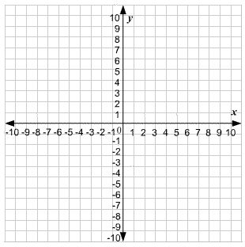 | Graph a line that passes through the point (4, -8) with a slope of 3.  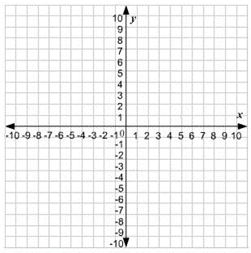 | Find the area and circumference:  (Diameter = 15 cm) | Find the surface area:  L = 3 in, W = .6 in, H = 4.5 in  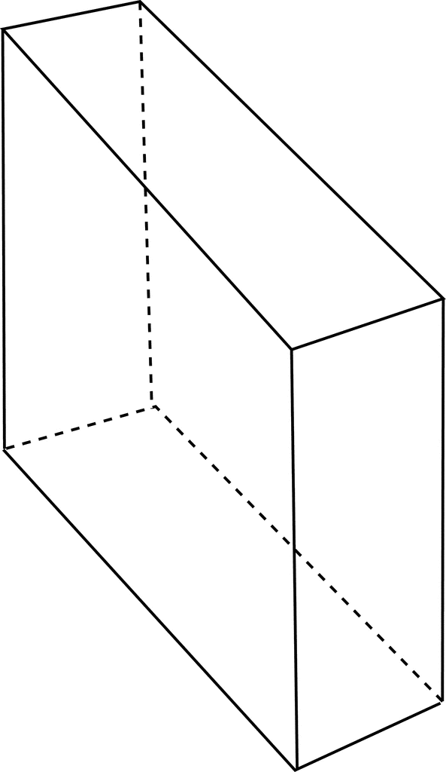
Scrambled: Use all four of the number set to create the first number. You must use each number once and only once, and you can use any combination of the four basic operations (+, -, x, ÷)  28: 1, 3, 4, 9 | Divide:  2.6604 ÷ .009 | Zina has 10 coins consisting of dimes and nickels, totaling $0.70. She has two more nickels than dimes. How many nickels does she have? | Of the 45 presidents, $\frac{1}{3}$ were elected to a second term. Of those elected to a second term, $\frac{1}{5}$one fifth were former vice presidents of the US. What fraction of the 45 presidents were elected to a second term AND were former vice presidents?
Write a linear equation for a line that passes through the points (-4, 6) and (2, -12) | Subtract:  11 $\frac{1}{12}$- 15 $\frac{2}{3}$ | Tranversal line t intersects parallel lines l and m. Angle 5 measures 109 $ͦ$. What is the measure of angle 4?  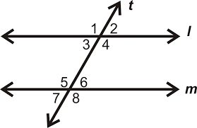 | Maya loves mango juice. There are 2 $\frac{3}{4}$servings remaining in the bottle. Maya pours only $\frac{1}{4}$serving into a glass at a time. How many glasses can Maya drink before the bottle is empty?
Solve for x:  3(2x – 4) = x + 8 | Add:  (2.675 x 10⁸) + (4.005 x 10⁷) | Serena buys a $96 bracelet for 20% off. How much does she pay for the bracelet? | Write in scientific notation.  .00020065

