Name ________________________________________ Sect ____8__________________ Weekly Math Maintenance # 27
Graph the equation y = -3x + 4  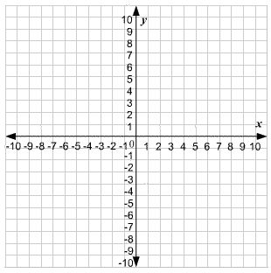 | Graph a line that passes through the point (-8, -2) with a slope of 4.  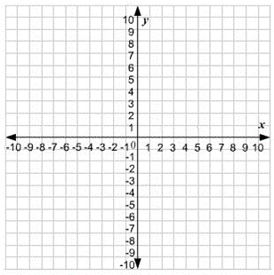 | What is the volume of the following prism?  H = 12.5 cm, AB = 6 cm²  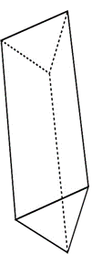 | Is the following graph a function?  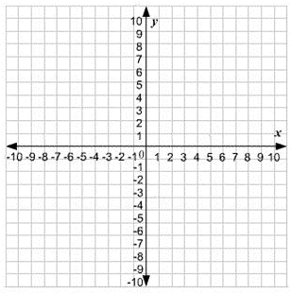
Scrambled: Use all four of the number set to create the first number. You must use each number once and only once, and you can use any combination of the four basic operations (+, -, x, ÷)  32: 3, 3, 8, 9 | Solve:  5 (4x -2) + 3 = 2x + 65 | Write a linear equation for a line that passes through the points (4, 1) and (2, -5) | David has 425 at-bats and gets 200 hits. Jimmy has 390 at-bats and gets 185 hits. Who has a higher batting average? Show your work.
Is the following table a function?  X -6 -4 -2 0 -6  Y 1 2 3 4 1 | Subtract:  $$12\frac{1}{15}-15\frac{2}{3}$$ | Add:  (1.92 x 10⁻³) + (9.21 x 10⁻²) | Ortega travels by horseback 216 miles over 9 days. If he continues to ride at the same rate over a total of 23 days, how far will he have traveled?
Solve the expression -3b – 9c for the values:  b = -5  c = -2 | Add:  24 – (-11) + (-3) – 8 + 45 – (-12) – 5 | What is the distance between the points (-8, -7) and (1, 5) | Perry’s Painting charges a one-time site-fee of $80 plus $40/hour. Pedro’s Painting does not charge a site-fee, but charges an hourly rate of $50. The Smiths need to hire a painter for a 6-hour job. Which painter would be the better deal?

