Name ________________________________________ Sect ____8__________________ Weekly Math Maintenance # 28
Add:  $$\frac{1}{6}+\frac{13}{15}+\frac{2}{5}$$ | Solve for x:  4 (7 – 2x) + 2 = -4x - 10 | Solve for d:  A = $\frac{2d}{b}$ | Write an equation for a line that passes through (2, 10) and (-3, 0)
Scrambled: Use all four of the number set to create the first number. You must use each number once and only once, and you can use any combination of the four basic operations (+, -, x, ÷)  25: 3, 3, 8, 9 | A triangle with coordinates (3,7),  (-2, 1) and (-7, -10) is rotated 270 ͦ counter-clockwise about the origin. List the new coordinates. | Solve:  (2.4 • 10⁷) + (9.8 • 10⁸) | $\frac{1}{5}$of the students at WPCS take the bus. There are 68 more students who walk than take the bus. $\frac{1}{3}$of the students at WPCS walk to school. How many students are enrolled at WPCS?
Draw a line with the equation  Y = - ½ x + 6  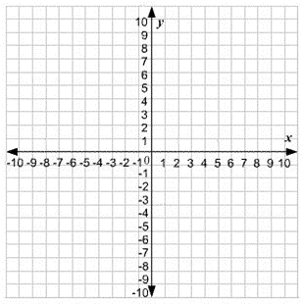 | What is the volume of the cylinder below?  R = 5.5 cm H = 8 cm  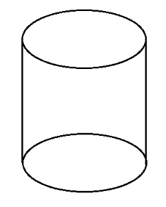 | Is the triangle shown below a right triangle? Show or explain why.  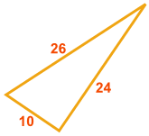 | Calculate the measure of angle 1.  The two horizontal lines are parallel  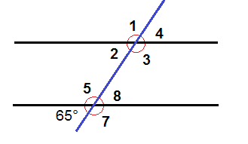
Three days ago, yesterday was the day before Sunday. What day will it be tomorrow? Explain. | Express in scientific notation:  .0030045 | Factor and simplify each square root. Leave answer with radical sign:  $\sqrt{325}$ | Express in simplest form:  $\frac{a^{3 }b^{7}c^{4}}{a^{4}c^{2}}$

