Name ________________________________________ Sect ____8__________________ Weekly Math Maintenance # 29
Solve for a:  ½ (4a – 6) – 7a = -111 | Add:  $$3\frac{1}{5}+2.7+42\% of 50$$ | What is the solution to the linear system:  3x + 2y = 16  -2x – 2y = -12 | The Smiths have a fence around their rectangular yard that measures 300 feet long. Their neighbors the Jones have a square yard that measures 2500 square feet in area. Both yards have the same width. What are the dimensions of the Smiths yard?
Scrambled: Use all four of the number set to create the first number. You must use each number once and only once, and you can use any combination of the four basic operations (+, -, x, ÷)  10: 2, 4, 8, 8 | .Does the following table represent a function? Explain.  X: -3 -2 -1 0 -1 -2 -3  Y: 6 7 8 9 8 7 6 | Convert to standard notation:  7.02 x 10⁻⁶ | Jimmy and Chase are on the same baseball team. Together they combine for 460 hits. Chase has 32 more hits than Jimmy. How many hits does Jimmy have?
Draw a line with the equation  y = ¼ x – 5  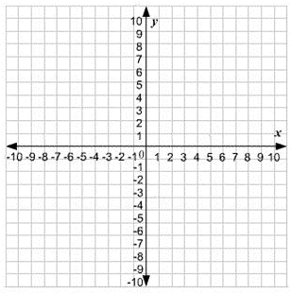 | Which shape has the greater area? Show your work.  R = 5 cm S = 9 cm | Simplify the expression:  3⁻⁴ | Bicycle rentals at the Boardwalk cost $8 plus $12.50/hour. A new bike at Walmart costs $226.75, including all taxes. After how many hours of renting a bike would the cost equal purchasing a new bike?
Brain Teaser: Jim and Wanda have some apples. If Jim gives Wanda an apple they will both have the same amount. If Wanda gives Jim an apple then Jim will have twice as many apples as Wanda. How many apples do they each have? | Divide:  .020601 ÷ .09 | What is 26.2 % of 312? | Complete the proportion:  $\frac{15}{x}=\frac{27}{90}$

