Name ________________________________________ Sect ____8__________________ Weekly Math Maintenance # 30
Find the mean, median and mode of the following set:  2.85, .05, 3.25, 24.2, 4.65, 1.95, 2.85 | Add:  $$\frac{4}{5}+ 1.85+1\frac{7}{10}$$ | What is the solution to the linear system:  y = 3x + 7  y = 2x + 6 | Three consecutive numbers add up to 654. What are the numbers?
Scrambled: Use all four of the number set to create the first number. You must use each number once and only once, and you can use any combination of the four basic operations (+, -, x, ÷)  56: 2, 5, 7, 9 | Solve:  3 (-4 – p) + 7 = -5p – 17 | Simplify:  $\frac{x^{4} y^{-3 }z}{x^{-2} y^{5 }z^{2} }$ | What is the slope of a line that passes through the points (0, -7) and (-11, 0)?
Draw a line with the equation  y = $-\frac{1}{3}$x - 6  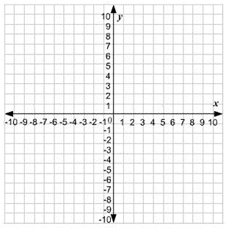 | Tony starts the week off with 10 apples. Each day he eats 2 apples. This is represented by the equation  y = -2x + 10. Graph the line that represents this equation.  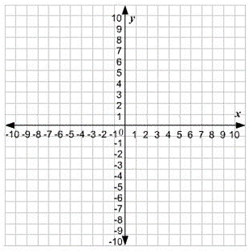 | Four friends ate together at a restaurant. The cost for each meal, without a tip, is shown below.  $11 $13 $13 $14  The total cost of the 4 meals with the tip was 1.2 times the total cost of the meals without the tip. The friends equally shared the total cost of the meals with the tip. How much did each friend pay? | Brain Teaser: You want to hire a employee for one month. You offer him reasonable wages, but the employee suggests an alternative. For the first day of work, he will be paid a penny. For the second day, two pennies. For the third day, four pennies. The salary for each subsequent day will be double the previous day's, until the one month term is over. Ignoring the legalities of such a situation, would it be a good idea to accept the potential employee's proposal?
A line passes through the points (5, 7) and (-10, -14). What is the y-intercept? | Find the volume: R = 3.2 cm  H = 8.1 cm | Simplify:  5⁻⁴ | Simplify:  $\frac{3}{5} ×\frac{5}{7}$ + 6

